Task 3: T₁ Measurement (Inversion Recovery)
The T₁ relaxation time is the time taken by a qubit to relax from the excited state |1⟩ to the ground state |0⟩ due to energy loss to the surrounding environment. It is one of the most important parameters used to characterize the performance of a qubit.
To measure T₁, the qubit is first prepared in the excited state |1⟩. It is then allowed to evolve freely under the effect of amplitude damping for different waiting times τ. As the waiting time increases, the probability of finding the qubit in the excited state decreases because the qubit continuously loses energy to the environment.
After each waiting time, the qubit is measured in the computational basis. Since quantum measurement is probabilistic, the measurement is repeated multiple times (shots). The fraction of measurements that return the excited state gives the excited-state population:
P(|1⟩) = (Number of times |1⟩ is measured) / (Total number of shots)
The excited-state population follows an exponential decay:
P(|1⟩)(τ) = A exp(-τ/T₁) + C
where A is the initial amplitude, C is a constant offset, and T₁ is the relaxation time.
By fitting the measured data to this exponential equation, the value of T₁ can be extracted. In this project, the evolution of the qubit is simulated using the Lindblad master equation, projective measurements are performed for different waiting times, and the resulting data is fitted using nonlinear least-squares fitting to estimate the relaxation time. The uncertainty in the fitted value is reported using a 95% confidence interval.

Code Implementation
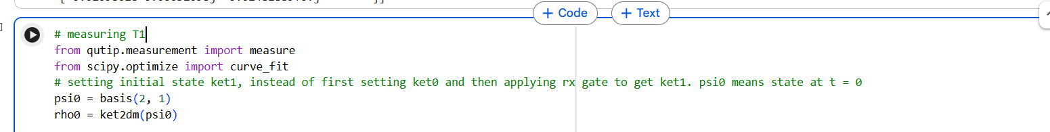 In the actual experiment, the qubit is initially in the ground state |0⟩. An Rx(π) gate is then applied to prepare it in the excited state |1⟩. Since the aim of the simulation is to study the evolution after this step, I directly define the initial state as |1⟩ using the basis() function and then convert it into a density matrix using ket2dm().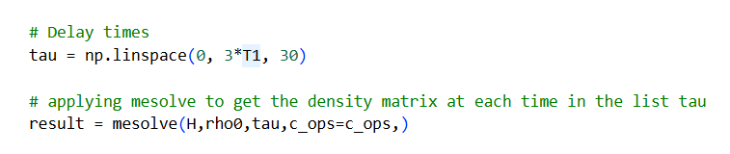
Next, I define tau, which contains all the waiting times for which the excited-state probability P(1) is calculated. These are the delay times for which the qubit evolves under amplitude damping.
I then use mesolve() to solve the Lindblad master equation. It takes the Hamiltonian, the initial density matrix, the list of waiting times (tau), and the collapse operators as input, and returns the density matrix corresponding to every value of tau. 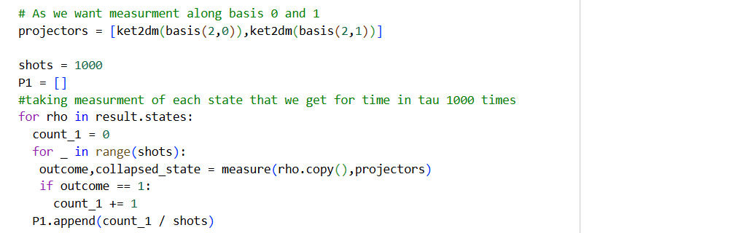
To simulate projective measurements, I define a list called projectors. This list contains the density matrix representation of the basis states |0⟩ and |1⟩, since the qubit is measured in the computational (Z) basis.
To calculate the excited-state probability, measuring the qubit only once for each value of tau is not sufficient because quantum measurements are probabilistic. Therefore, I perform multiple measurements for every density matrix. The variable shots stores the total number of measurements performed for each value of tau.
I then loop over every density matrix returned by mesolve(). For each density matrix, I perform 'shots' number of measurements using the measure() function. Every time the measurement outcome is 1, I increment the counter count_1. After all the measurements are completed, the probability of finding the qubit in the excited state is calculated as P(1) = count_1 / shots.
This probability is appended to the list P1. Repeating this process for every value of tau gives the complete inversion recovery data.
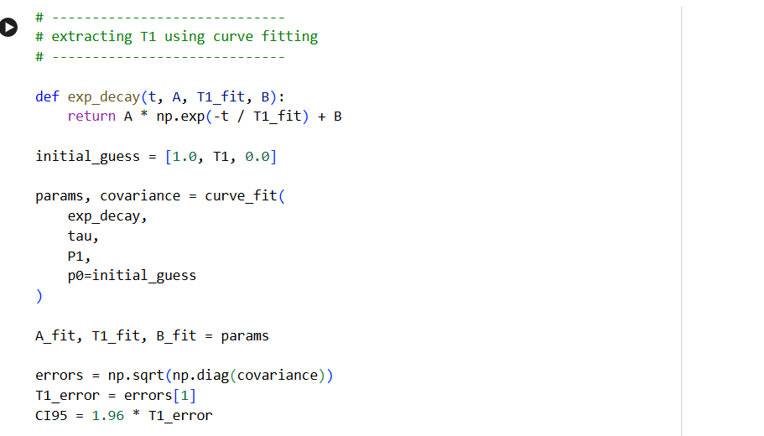Next, I define the exponential fitting function P(1) = A exp(-t/T₁) + B and use the curve_fit() function from SciPy to fit the measured data. The function returns the best-fit parameters along with the covariance matrix, from which the estimated value of T₁ is extracted.
The standard error is obtained from the covariance matrix and is used to calculate the 95% confidence interval as CI95 = 1.96 × (standard error).
Finally, I plot the measured excited-state probabilities as blue scatter points and the fitted exponential decay as a red curve. The scatter points represent the simulated experimental measurements, while the fitted curve is used to estimate the relaxation time T₁.

